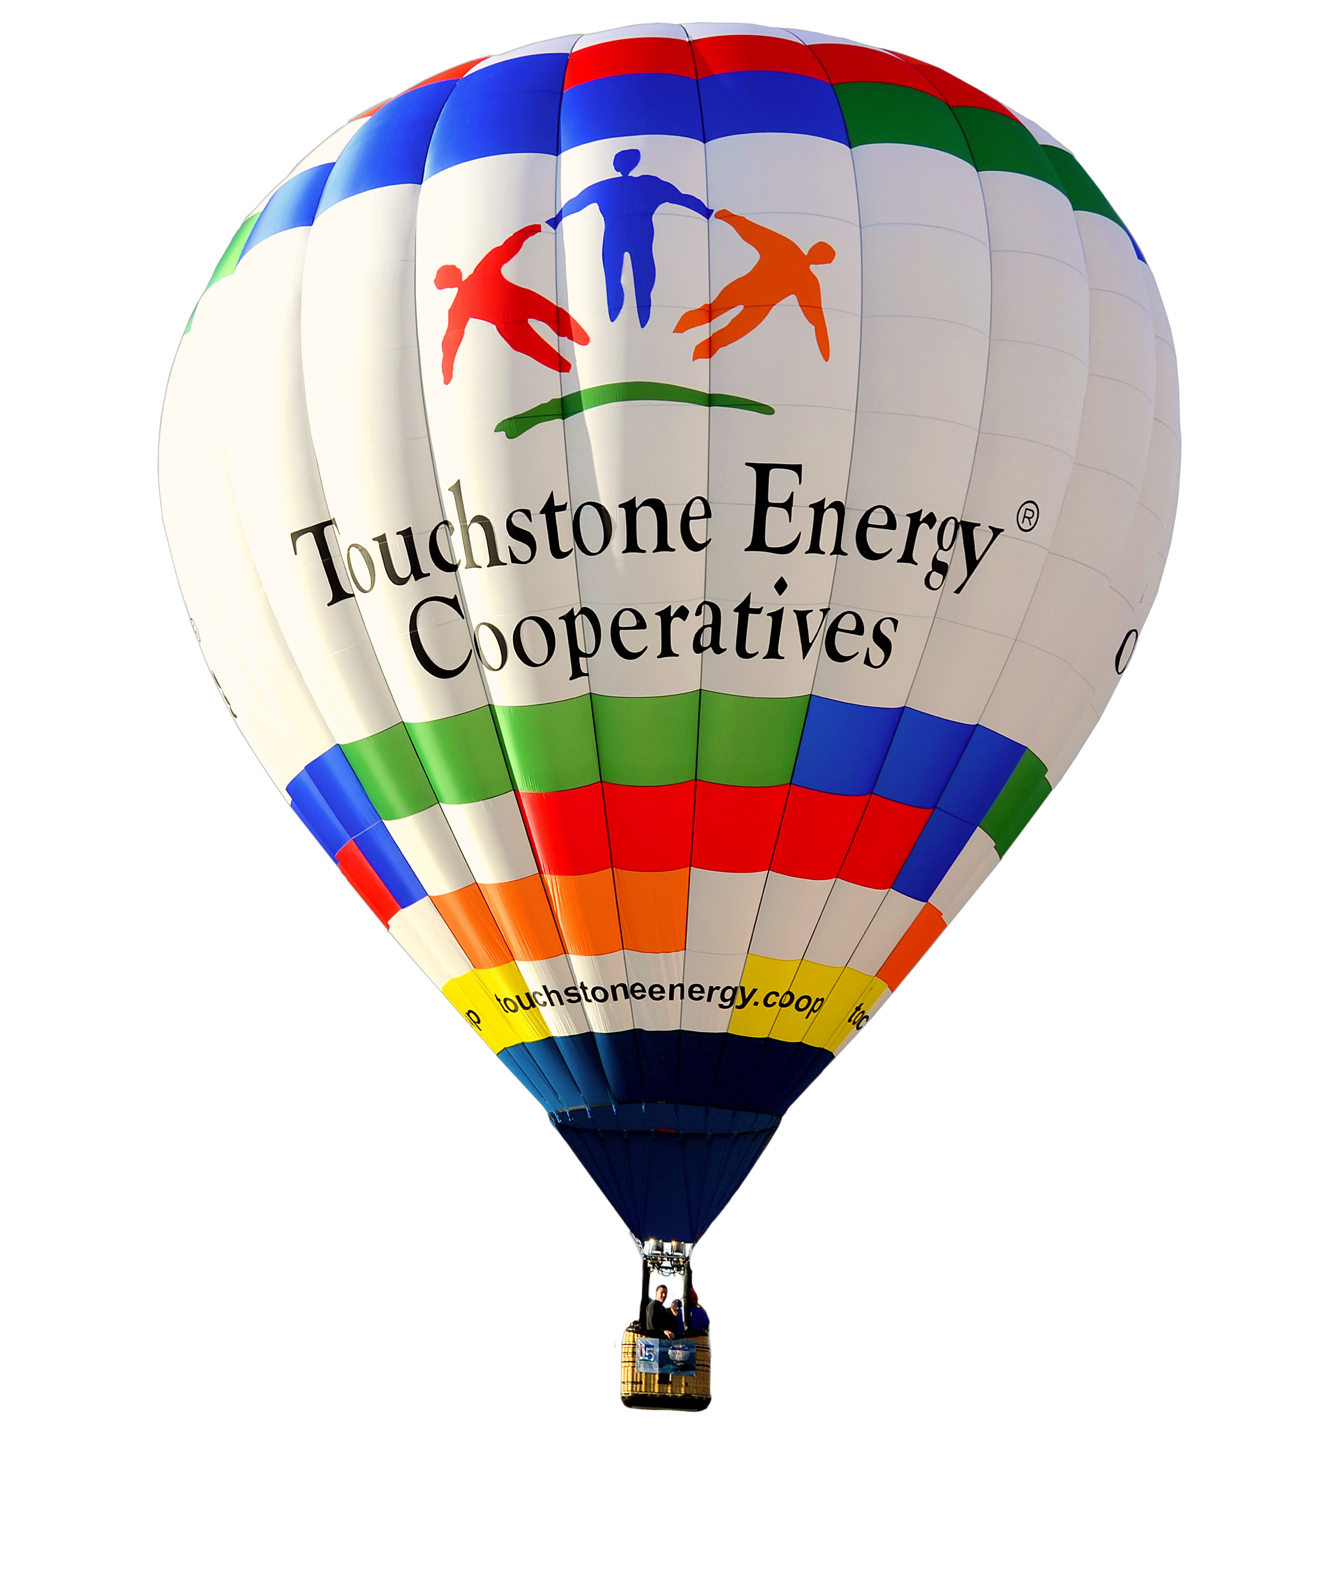
//For Immediate Release//

For more information, contact:
<insert name(s) and phone number(s)>

<Insert co-op name> to sponsor the Touchstone Energy® Cooperatives hot air balloon at xx event

The <insert name of town> community is invited to join the festivities

<Insert date, location> -- On <insert date>, the Touchstone Energy hot air balloon and experienced pilot will make a special appearance at <insert event>.

From <insert times>, the hot air balloon will be available for tethered rides (if applicable) and photos. <Insert co-op name> invites the <insert name> community to come to <insert location of the balloon> to take part in the fun.

<Highlight details about the event>

<Insert quote from co-op or community leader about their excitement for the event and the balloon being there.>

<Insert pilot’s name> will be on hand to answer questions and help with the event. <Insert specifics about pilot accolades available at this link https://www.cbaballoon.com/hot-air-balloon-team.html>

While there, meet with our <insert co-op’s name> employees, along with <insert community leaders if applicable>.

The Touchstone Energy Hot Air Balloon Program is n the second longest tenured corporate balloon program in the country. The balloon program has been involved in over 650 balloon events, festivals and annual meetings. Since 1999, the hot air balloon program has demonstrated its commitment to community by giving more than $320,000 back to local communities in philanthropic donations.

About the Touchstone Energy® Hot Air Balloon Program
The Touchstone Energy® Hot Air Balloon is intended to serve as a goodwill ambassador for Touchstone Energy Cooperatives and its 700+ member-Cooperatives. As the second longest running national balloon program the brand is recognized at events throughout the country. The balloons are as large as 77,000 cubic feet and stand over 77 feet tall and are 60 feet wide when fully inflated. They carry a pilot and two average size passengers. Touchstone Energy electric cooperatives have brought the joy of ballooning and the cooperative difference to more than 100,000 visitors.

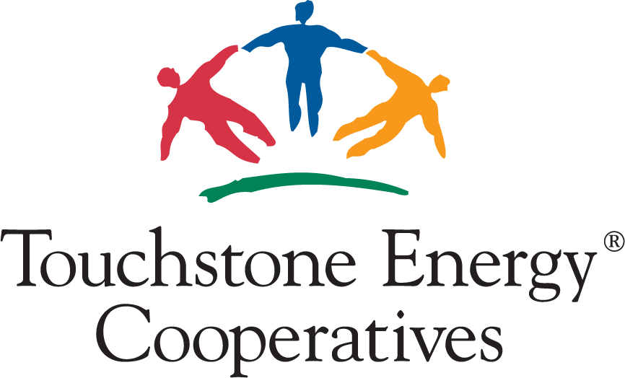
About Touchstone Energy® Cooperatives
Touchstone Energy Cooperatives (www.touchstoneenergy.com) is a national brand and energized network of electric cooperatives across 47 states that provides resources and leverages partnerships to help member cooperatives and their employees better engage and serve their members. By working together, Touchstone Energy cooperatives stand as a source of power and information to their 32 million member-owners every day.

Download the Touchstone Energy Experience App and scan here for press release templates and examples.

